8.1.1 MULTIPLICATION OF 2 MATRIX
ALGORITHM
- Start
- Read size n
- Read matrix A
- Read matrix B
- Create empty matrix result of size n ⋅ n
- For each row i
- For each column j
- Set sum = 0
- For k = 0 to n-1
- sum = sum + A[i][k] ⋅ B[k][j]
- Store sum in result[i][j]
- Display result
- Stop
FLOWCHART
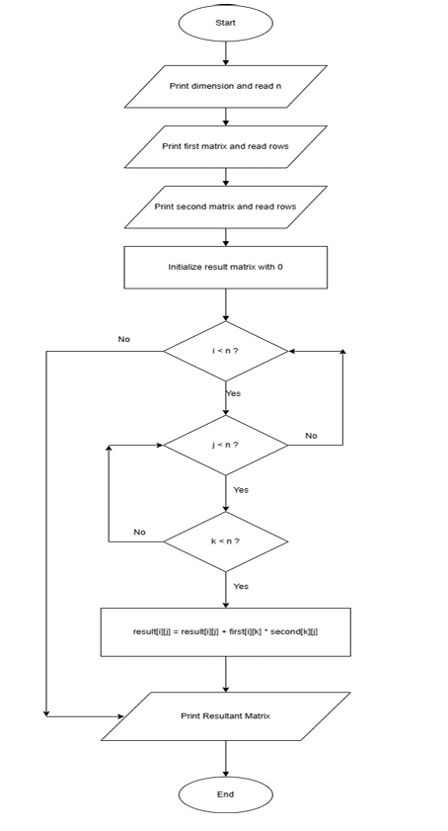
PROGRAM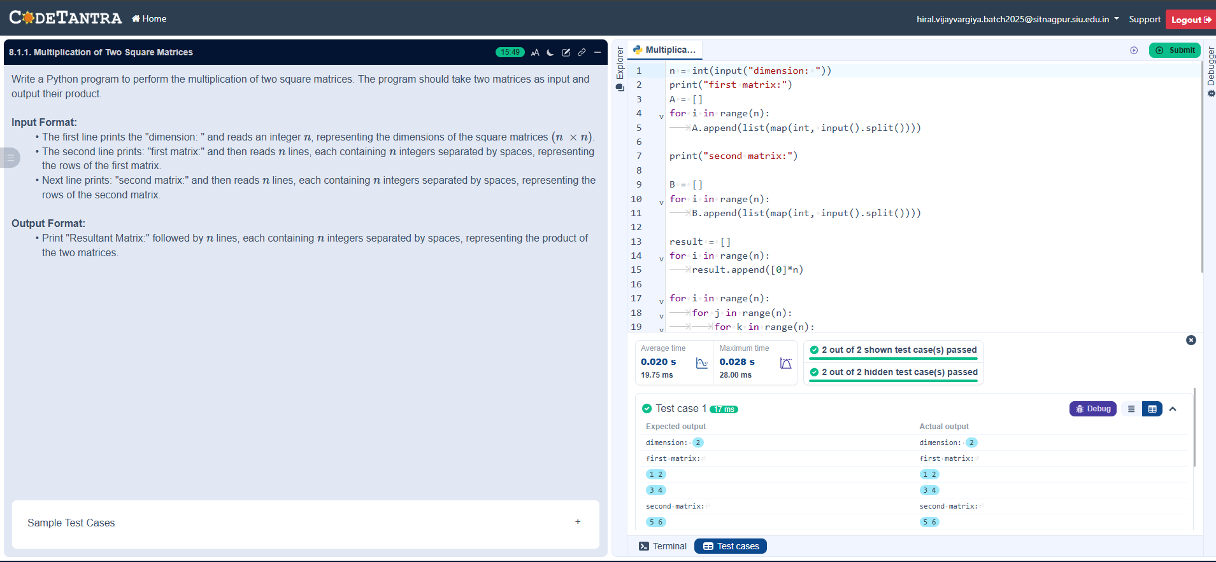

8.1.2 PRIME NO IN A GIVEN RANGE
ALGORITHM
- Start
- Read start
- Read end
- Set found = False
- For num from start to end
- If num > 1
- Set prime = True
- For i from 2 to √num
- If num % i == 0
- Set prime = False and break
- If prime == True
- Print num
- Set found = True
- If found == False
- Print "No primes"
- Stop
FLOWCHART
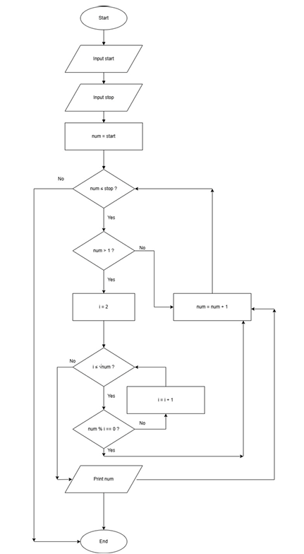
PROGRAM
